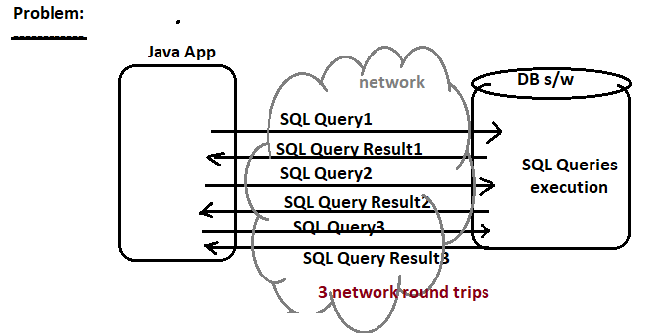

1. In normal JDBC app, we use network for 2*n times in order to execute the n sql queries.

Ex:- To execute the 3 sql queries , JDBC app should use network 6 times.

1. Utilizing the network more no.of times reduce the performance the JDBC application because It is time consuming process.

**Solution: Use Batch Processing.**

Keep the multiple related sql queries in batch and send batch to DB s/w to execute. The Queries in Batch are executed one by one in DB s/w. similarly results of sql queries is given to JDBC app as batch.

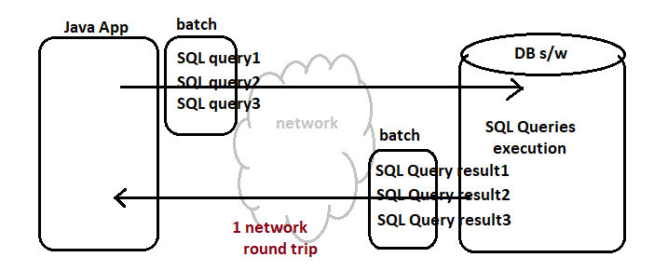

When JDBC app uses Batch processing , JDBC app will use network only one time in order to execute the SQL query.

**Procedure to add sql Queries to Batch and Executing Batch in DB s/w:**

1. Add queries to batch.

Public void add batch(String SQL query);

This method present in simple Statement Interface.

Note:- **To batch, we can add only non-select queries.**

1. Send and execute batch of sql queries.

Int [] executeBatch();

**Note:- The success or failure of one sql query of batch will not affect the execution of other sql queries in same batch.**



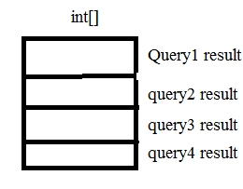

1. Process the result .

**Example:-**

package com.raos.jdbc;

import java.sql.Connection;

import java.sql.DriverManager;

import java.sql.ResultSet;

import java.sql.SQLException;

import java.sql.Statement;

public class Sample {

public static String qur="select eno,ename from emp";

public static void main(String[] args) throws InterruptedException {

try(Connection con=DriverManager.getConnection("jdbc:oracle:thin:@localhost:1521:xe","sukumar","sukumar");

Statement s=con.createStatement();

){

if(s!=null) {

s.addBatch("update emp set ename='sula' where eno=6");

s.addBatch("insert into emp values(8,'sulamaha')");

int []result=s.executeBatch();

int i=0,total=0;

while(i<result.length) {

total=total+result[i];

i=i+1;

}

System.out.println("No.of Records Updated:"+total);

}

}

catch(SQLException e) {

System.out.println(e.getMessage());

}

}

}

Output:-

No.of Records Updated:2